Sample message 1:
[business name] is proud to support this year’s CFUW Orillia Homes for Scholarships Tour on Sunday, June 7th from Noon to 5 p.m. We encourage you to explore their website for details on the event’s beautiful homes, fabulous door prizes, and scrumptious experiences.
Sample message 2:
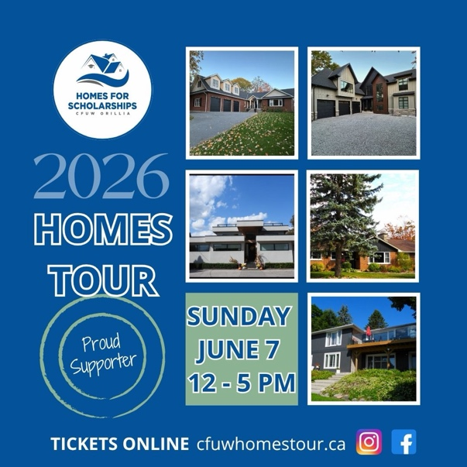
FIVE STUNNING LOCATIONS | TEA & TREAT TO GO | FABULOUS DOOR PRIZES…So many reasons to purchase your ticket to this year's CFUW Orillia Homes for Scholarships Tour, proudly supported by [business name]. Details at cfuwhomestour.ca. All proceeds support scholarships for young women pursuing post-secondary education.
Sample message 3:
Join CFUW Orillia Sunday, June 7th between Noon and 5 p.m. for this year’s Homes for Scholarships Tour. [Business name] is proud to support the event, which funds scholarships for young women pursuing post-secondary education. Treat yourself to an afternoon of entertainment and exploration knowing you are supporting the influencers of tomorrow.
https://www.instagram.com/cfuworilliahomestour/
https://www.facebook.com/CFUWOrillia
#homesforscholarships #cfuworillia #shoplocal #OrilliaLakeCountry
@cfuworillia @cfuwhomestour

